Name: Mohamed Hamza Mohame Soliman.

Class: 31

Phone: 01553528720

ID:691

**Topic: Artificial Intelligence**

Intro to Artificial Intelligence:

In computer science, artificial intelligence (AI), sometimes called machine intelligence, is intelligence demonstrated by machines, in contrast to the natural intelligence displayed by humans and animals.

Screenshots

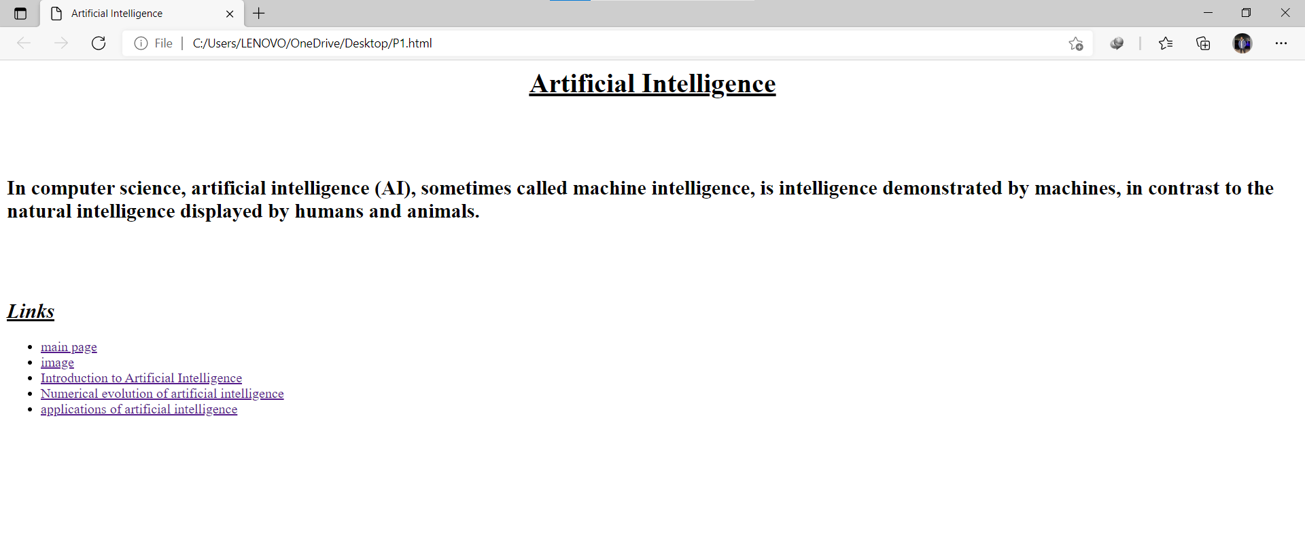

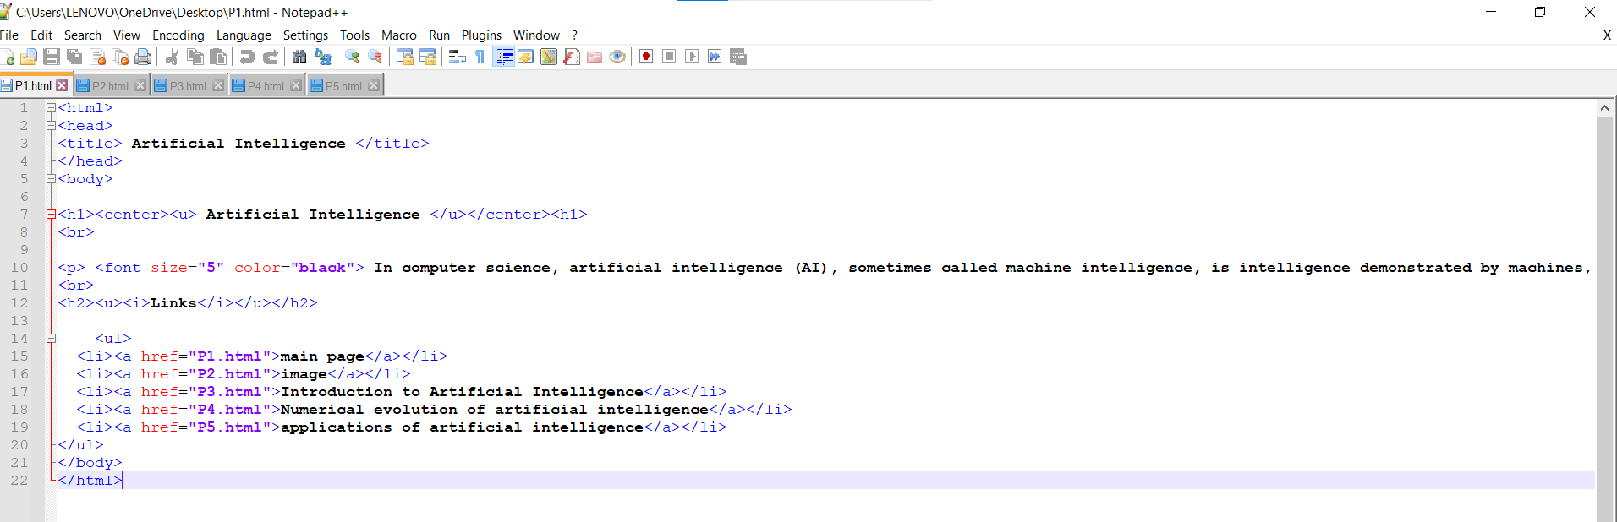

**Source code:**



